|  |
| --- |
| **Punchh Integration Setup Instructions**  **for**  **PixelPoint** |

Table of Contents

1. Introduction 3

2. POS Setup and Configuration for PixelPoint 3

2.1. Prerequisites 3

2.2. Configuration 3

2.2.1. Configuration at the File Level 3

2.2.2. Configuration at the Application Level 6

# Introduction

Punchh **Point of Sales** (**POS**) Integration is done via a proxy web service, which is running on a local network. POS can talk to the service either via HTTP POST calls or via direct socket calls. Proxy service forwards calls to the Punchh backend and takes care of logging, heartbeat and queuing the data in case of network outages.

POS Integration is done differently for each POS system, but there is a common component that has to be installed first. That is the **Punchh Integration Service** (PIS).

The required steps for installing the PISon Windows and Lunix via the Punchh Installer are covered by the **Punchh Integration Setup Instructions for Punchh Integration Service** document.

A purpose of this Instruction is to complete the Punchh Integration Setup for the specific POS – **PixelPoint**.

# POS Setup and Configuration for PixelPoint

## Prerequisites

1. You must complete the **Punchh Integration Service** setup according to the “**Punchh Integration Setup Instructions for Punchh Integration Service**” successfully
2. Verify, that you have the valid “PixelPoint” user name and password which gives you access to the application
3. Verify that the “1-PixelSQL Engine 10” is up and running:

|  |
| --- |
| **"C:\Program Files\SQL Anywhere 10\win32\dbsrv10.exe" C:\PIXELSQL\PIXELSQLBASE10.db -n PixelSQLbase_EOI -x TCPIP -ti 0 -c 128M -qp -zt -ch 50% -gb high** |

1. Verify that the “2-License Manager” is up and running:

|  |
| --- |
| **C:\PixelPOS\LicenseManager.exe –virtualkeys** |

1. Verify that the **Punchh.dll** file was put by the Punchh Installer into the ‘**D:\Punchh\Punchh Integration\POS\PixelPoint**’ directory (See the ***Execute the Setup.exe installer*** section at the **Punchh Integration Setup Instructions for Punchh Integration Service** document)

For instance:

|  |
| --- |
| **dir "D:\Punchh\Punchh Integration\POS\PixelPoint\Punchh.dll"** |

## Configuration

### Configuration at the File Level

#### Copy Punchh.dll into C:\PixelPOS\DLLS

1. Copy **punchh.dll** into **C:\PixelPOS\DLLS**

* Copy **punchh.dll** from the **D:\Punchh\Punchh Integration\POS\PixelPoint** directory into **C:\PixelPOS\DLLS\punchh.dll.**
* Verify that the punchh.dll was copied successfully:

|  |
| --- |
| **dir C:\PixelPOS\DLLS\punchh.dll** |

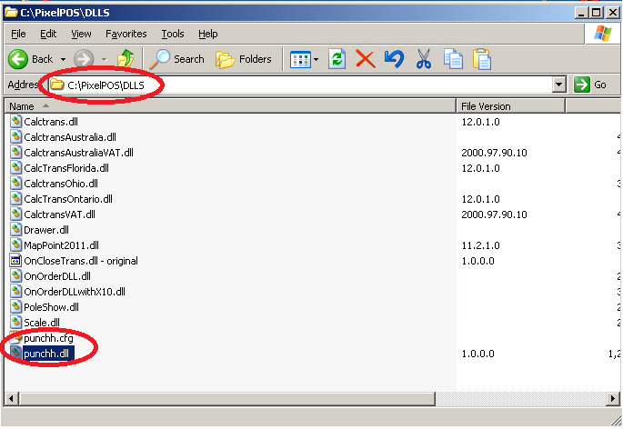

#### Stop the Punch service

Navigate into “Control Panel -> Administrative Tools -> Services” and stop the Punchh service:

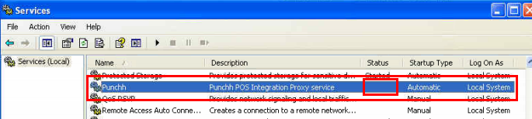

#### Verify and Update the Punchh.cfg file in C:\PixelPOS\DLLS

1. Execute **ipconfig** and get the IP address of the **Back of the House** server:

IP Address. . . . . . . . . . . . : 10.1.10.36

1. Open the **C:\PixelPOS\DLLS\punchh.cfg** file and add the IP Address from above:

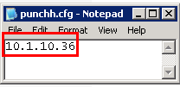

**\*NOTE**: this file may NOT be needed. If there are issues connecting from terminals create that file and specify the IP address of the BOH system. That IP address should be accessible from terminals.

#### Verify and Update the Punchh.cfg file in the Config directory

1. Make sure that the Punchh.cfg configuration was generated by the Punchh Installer in an appropriate location, and it was updated with the API Key specific for your location according to the ***Punchh Integration Setup Instructions for Punchh Integration Service*** document. For instance, "**D:\Punchh\Punchh Integration\Config\Punchh.cfg**"
2. Review the Values that expected to be available in the **Punchh.cfg** file:

|  |
| --- |
| **<PunchhConfig d1p1:type="PunchhConfig" xmlns:d1p1="http://www.w3.org/2001/XMLSchema-instance">**  **<Integrator>Generic</Integrator>**  **<LogLevel>4</LogLevel>**  **<LocationId>3671df83bac55cdebd1e5f2268054aaf</LocationId>**  **<Staging>false</Staging>**  **<PrintBarcodes>true</PrintBarcodes>**  **</PunchhConfig>** |

The API_Key parameter for the particular store location shell be updated per the **Punchh Integration Setup Instructions for Punchh Integration Service** document you completed first and should be looking as it is shown below:

**\*NOTE:** Information regarding all the parameters in the **Punchh.cfg** file, is available in the **Punchh Integration Setup Instructions for Punchh Integration Service** document you completed first

1. **Update the <POS>Generic</POS> parameter**
2. **Enter the value PixelPoint** **instead of the “*Generic*”** one in Punchh.cfg:

|  |
| --- |
| **<PunchhConfig d1p1:type="PunchhConfig" xmlns:d1p1="http://www.w3.org/2001/XMLSchema-instance">**  **<Integrator>PixelPoint</Integrator>**  **<LogLevel>4</LogLevel>**  **<LocationId>3671df83bac55cdebd1e5f2268054aaf</LocationId>**  **<Staging>false</Staging>**  **<PrintBarcodes>true</PrintBarcodes>**  **</PunchhConfig>** |

1. Save the updated Punchh.cfg

#### Start the Punchh service

Navigate into **Control Panel -> Administrative Tools -> Services** and start the Punchh service:

**OPTIONAL:** You may want to set the following service recovery options:

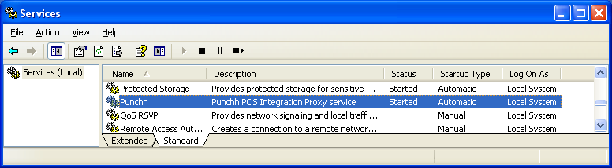 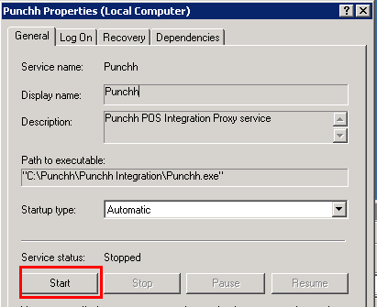 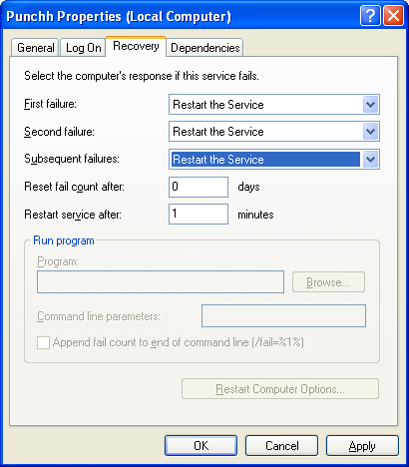

#### Generating the PixelPoint.cfg file

The **PixelPoint.cfg** file is generated by the Punchh Service once after updating the <POS>**Generic**</POS> parameter with **PixelPoint** in the **Punchh.cfg** and restarting the Punchh service

1. Verify that the **PixelPoint.cfg** file is generated and put into the appropriate directory after starting the Punchh service.

For instance, “**D:\Punchh\Punchh Integration\Config\PixelPoint.cfg”**

|  |
| --- |
| **<PixelPointConfig d1p1:type="PixelPointConfig" xmlns:d1p1="http://www.w3.org/2001/XMLSchema-instance">**  **<PathToPixelPoint>C:\PixelPOS</PathToPixelPoint>**  **<CouponId>default</CouponId>**  **<Port>2001</Port>**  **</PixelPointConfig>** |

1. Verify the latest log file (for instance, in the “**D:\Punchh\Punchh Integration\Logs**” directory). If there are any issues, then the Punchh Service reports any errors and warnings in the log file for each location

**\*NOTE:** the Punchh service has to be restarted every time after you edited the config files.

1. Verify log files

### Configuration at the Application Level

**\*NOTE**: screenshots below maybe different depending on your version of the POS.

#### Start the PixelPoint application

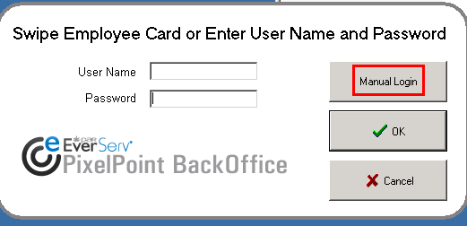 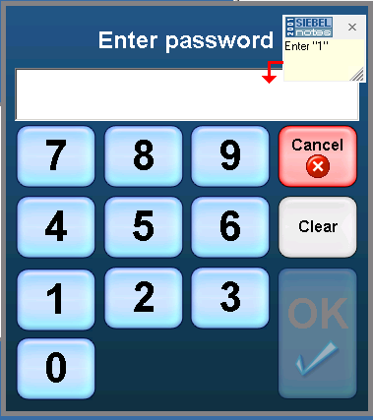

#### Coupon Setup

Navigate to General Setup -> Coupon Setup

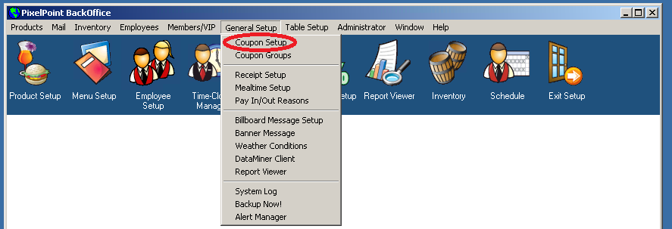

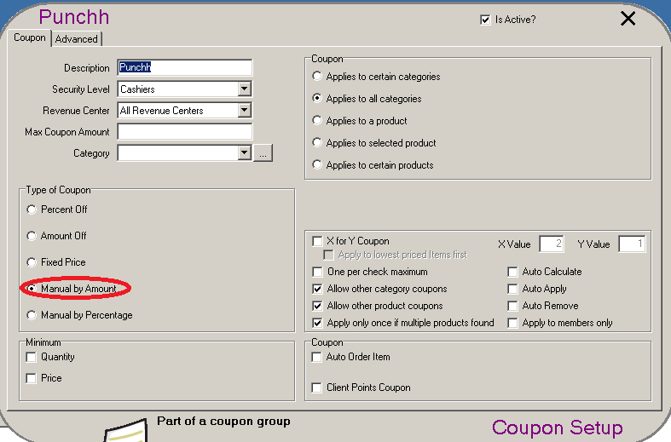 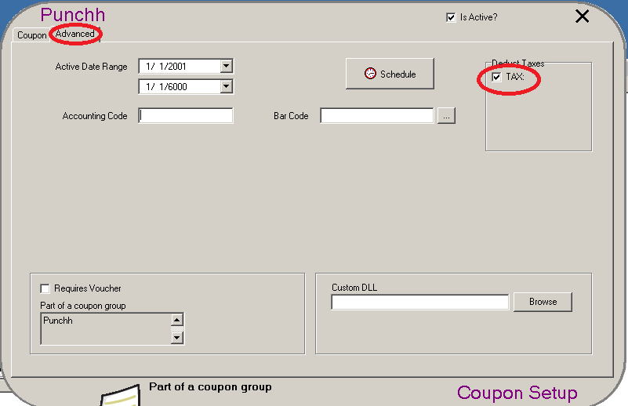

#### System Setup

Navigate to Administrator -> System Setup

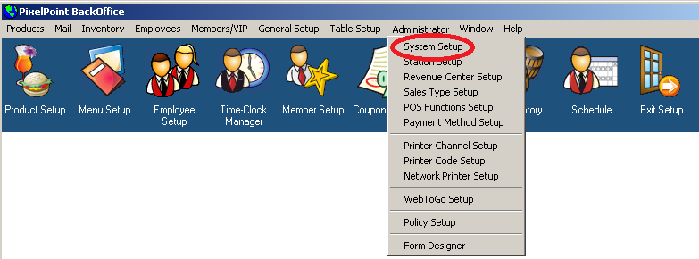 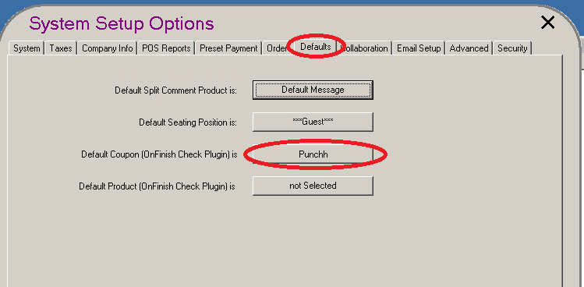

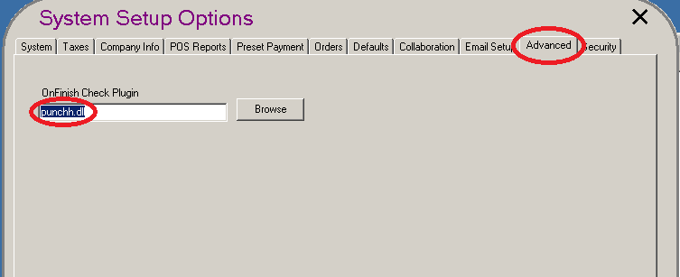

#### Create a Button

Navigate to Administrator -> Form Designer

